Math Teachers’ Circle
American Institute of Mathematics
Palo Alto, CA

2014-15 Meeting Schedule
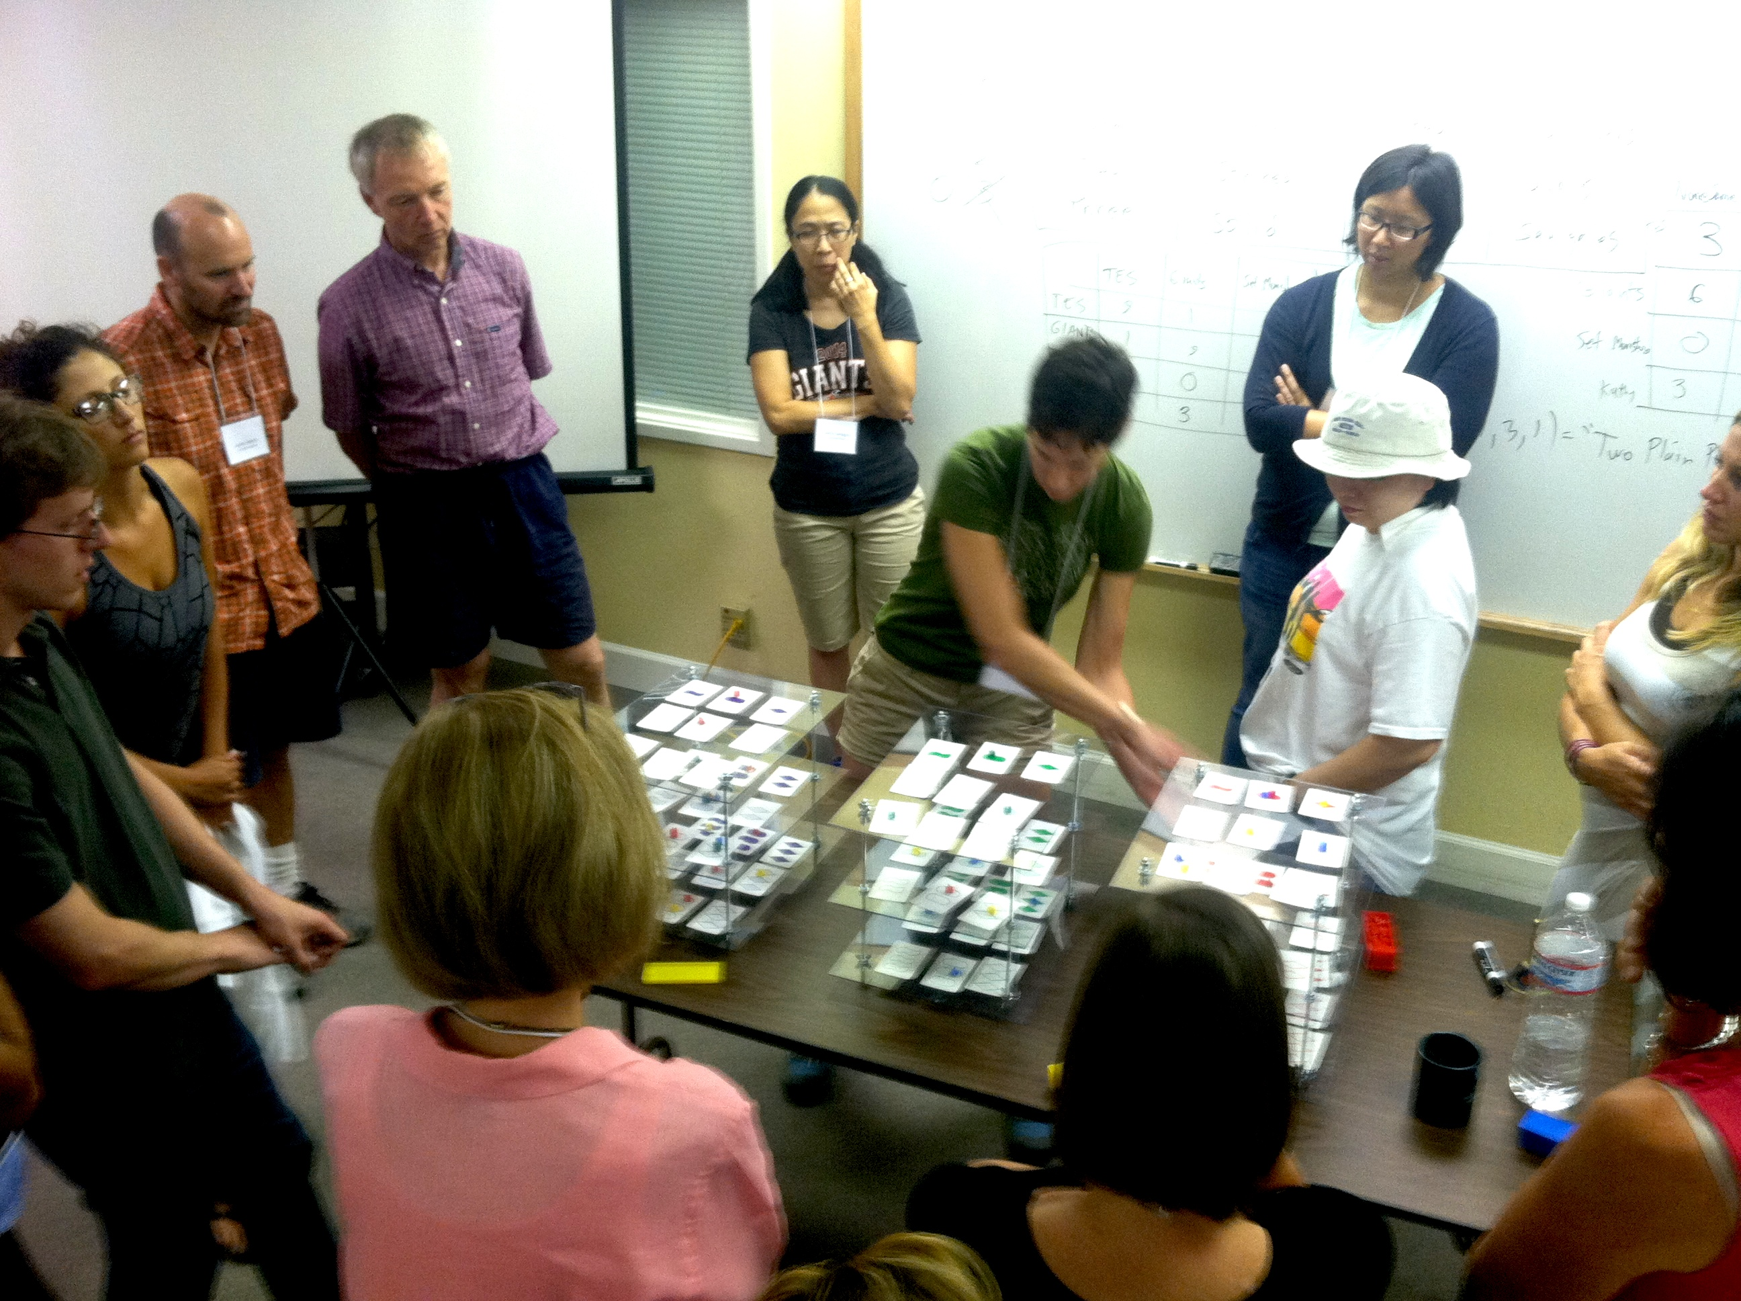

Every month from September to April (except December), the AIM Math Teachers’ Circle will offer an evening meeting for middle school math teachers interested in exploring accessible, exciting topics in mathematics. All teachers are welcome to attend. Meetings include dinner, which is complimentary.

Meetings are held from 5 – 8 PM on the second Tuesday of the month at AIM, unless otherwise specified. The 2014-15 meeting schedule is as follows:

September 9
October 7 (first Tuesday)
Novevember 11
January 13
February 10
March 10
April 14

For more information, please visit our website www.mathteacherscircle.org/member-circles/aim/ or contact hana@aimath.org.

